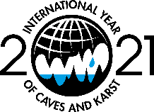
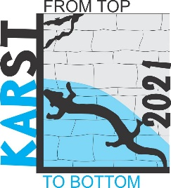
Online Multidisciplinary Conference
for young karst researchers and professionals
“Karst: From Top to Bottom”, June 6 – 7, 2021

REGISTRATION FORM

Name: ____________________________________________________________________

Surname: ____________________________________________________________________

Title: ____________________________________________________________________

Affiliation: ____________________________________________________________________

Company: ____________________________________________________________________

Country: ____________________________________________________________________

Email: ____________________________________________________________________

Participation to the conference:
Oral presentation Attendance only

Title of the abstract: ____________________________________________________________________

Authors of the abstract: _________________________________________________________________

Preferred Thematic Area:

Correlation – Water cycle in karst, groundwater genesis, flow paths, hydrodynamic and modeling

Coordination – Water management, engineering in karst, threats, contamination and protection of environment and groundwater in karst, monitoring

Cohabitation – Geodiversity and biodiversity, speleology and show caves

Deadline for abstract submission – 30 April 2021

Please send the form to: ljiljana.vasic@rgf.bg.ac.rs; veljko.marinovic@yahoo.com

